**BDD Framework Setup Steps:**

Step 1: Create new project

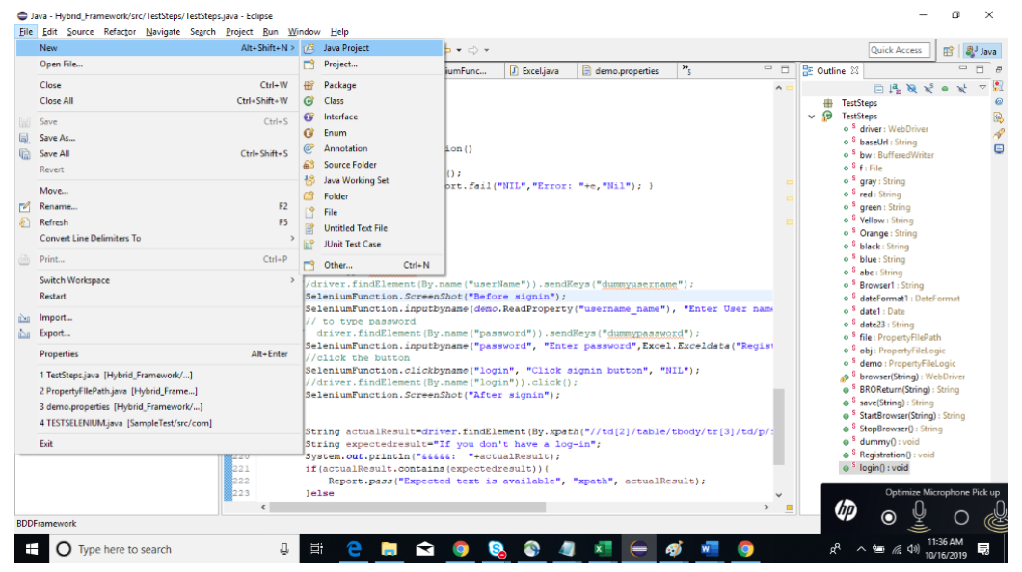

Step 2: Select the BDD Framework

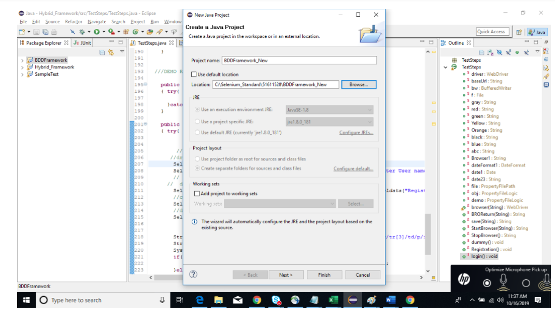

Step 3: Add Below Jars under project

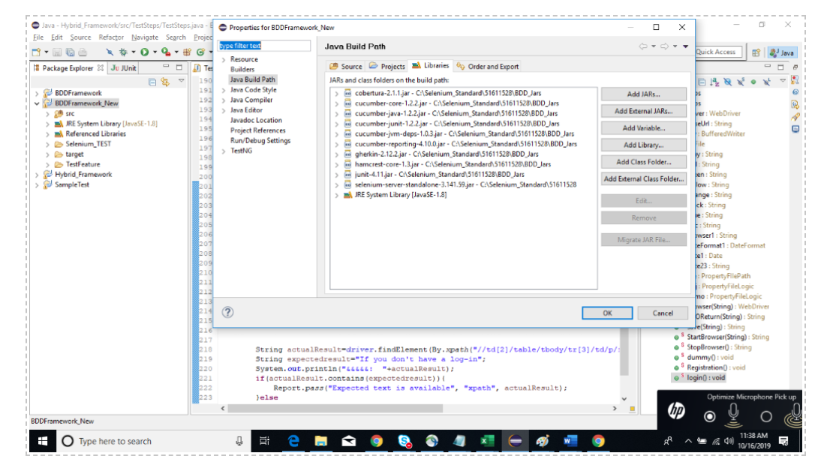

Step 4: Go to C:\Selenium_Standard\51611528\BDDFramework_New\src\TestRunner\Runner.java

Then run as “Junit Test”

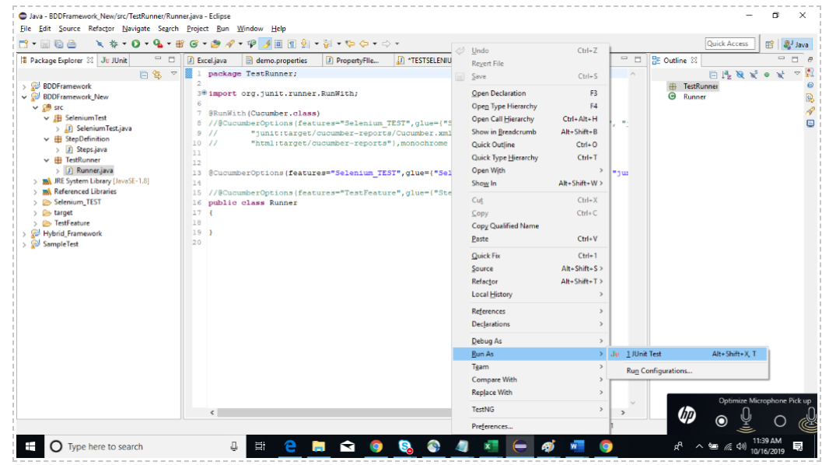

Step 5: Once the execution done report will be stored in below path:

